**Praktikum Inheritance dan Polimorfisme  
Desain Web**

**Kelas A**



Oleh :

Adjie Firmansyah

4523210004

Dosen :

# **Adi Wahyu Pribadi, S.Si., M.Kom**

**S1 Teknik Informatika**

**Universitas Pancasila**

**binatang.java**

**public class binatang {**

**protected String nama;**

**public binatang (String nama){**

**this.nama = nama;**

**}**

**public void bersuara(){**

**System.out.println("mbek");**

**}**

**}**

**kucing.java**

**public class kucing extends binatang{**

**public kucing(String nama){**

**super(nama);**

**}**

**public void bersuara(){**

**System.out.println("Ngeong");**

**}**

**}**

**cemeng.java**

**class cemeng extends kucing {**

**public cemeng (String nama){**

**super(nama);**

**}**

**public void bersuara(){**

**System.out.println("Meong");**

**}**

**}**

**App.java**

**public class App {**

**public static void main(String[] args) {**

**binatang kambing = new binatang ("kambing");**

**kucing mudreg = new kucing ("mudreg");**

**cemeng mocha = new cemeng ("mocha");**

**kambing.bersuara();**

**mudreg.bersuara();**

**mocha.bersuara();**

**}**

**}**

**Output**

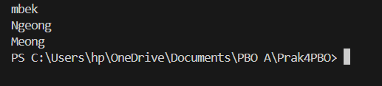

**mobil.java**

**public class mobil {**

**protected String nama;**

**public mobil (String nama){**

**this.nama = nama;**

**}**

**public void klakson(){**

**System.out.println("teet");**

**}**

**}**

**sedan.java**

**public class sedan extends mobil{**

**public sedan(String nama){**

**super(nama);**

**}**

**public void klakson(){**

**System.out.println("Tiin");**

**}**

**}**

**App.Single**

**public class AppSingle {**

**public static void main(String[] args) {**

**mobil m1 = new mobil ("vios");**

**sedan m2 = new sedan ("Hino");**

**m1.klakson();**

**m2.klakson();**

**}**

**}**

**Output**

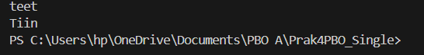

**karyawan.java**

**public class karyawan {**

**protected String nama;**

**public karyawan (String nama) {**

**this.nama = nama;**

**}**

**public void kerja() {**

**System.out.println("Karyawan kerja");**

**}**

**}**

**Dosen.java**

**public class Dosen extends karyawan {**

**public Dosen (String nama) {**

**super(nama);**

**}**

**public void kerja() {**

**System.out.println("Dosne mengajar");**

**}**

**}**

**Staf.java**

**public class Staf extends karyawan {**

**public Staf (String nama) {**

**super(nama);**

**}**

**public void kerja() {**

**System.out.println("Staf bantu dosen");**

**}**

**}**

**AppHierarchical.java**

**public class AppHierarchical {**

**public static void main(String[] args) {**

**karyawan Wahyu = new karyawan ("Wahyu");**

**Dosen Amir = new Dosen ("Amir");**

**Staf Melan = new Staf ("Melan");**

**Wahyu.kerja();**

**Amir.kerja();**

**Melan.kerja();**

**}**

**}**

**Output**

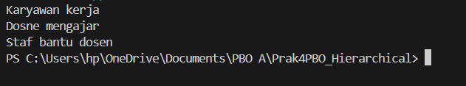

**MobilSport.java**

**public class MobilSport {**

**private String nama;**

**public MobilSport (String nama){**

**this.nama = nama;**

**}**

**public void gigi(int g){**

**System.out.println(this.nama + "Mobil Masuk Gigi ke-" + g);**

**}**

**public void gigi(int g, int t){**

**System.out.println(this.nama + "Mobil Masuk Gigi ke-" + g + " Dengan Turbo " + t);**

**}**

**}**

**AppPolymorphism.java**

**public class AppPolymorphism {**

**public static void main(String[] args) {**

**MobilSport jaguar = new MobilSport("Jaguar");**

**jaguar.gigi(1);**

**jaguar.gigi(2);**

**jaguar.gigi(3);**

**jaguar.gigi(4);**

**jaguar.gigi(5);**

**jaguar.gigi(5);**

**jaguar.gigi(5);**

**jaguar.gigi(5);**

**jaguar.gigi(5);**

**jaguar.gigi(5);**

**jaguar.gigi(5,1);**

**jaguar.gigi(5,2);**

**jaguar.gigi(5,3);**

**jaguar.gigi(5,4);**

**jaguar.gigi(5,5);**

**}**

**}**

**Output**

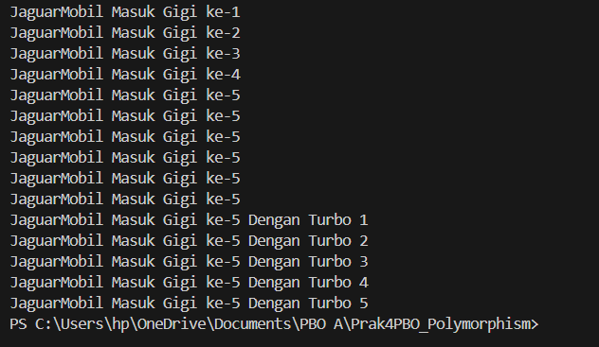

**BangunDatar.java**

**public class BangunDatar {**

**float luas(){**

**System.out.println("Menghitung luas bangun datar");**

**return 0;**

**}**

**float keliling(){**

**System.out.println("Menghitung keliling bangun datar");**

**return 0;**

**}**

**}**

**Lingkaran.java**

**class Lingkaran extends BangunDatar {**

**private int r;**

**public Lingkaran(int r) {**

**this.r = r;**

**}**

**@Override**

**public float luas(){**

**return (float) (Math.PI * r * r);**

**}**

**@Override**

**public float keliling(){**

**return (float) (2 * Math.PI * r);**

**}**

**}**

**Persegi.java**

**class Persegi extends BangunDatar{**

**private int sisi;**

**public Persegi(int sisi) {**

**this.sisi = sisi;**

**}**

**@Override**

**public float luas() {**

**return this.sisi * this.sisi;**

**}**

**@Override**

**public float keliling(){**

**return this.sisi * 4;**

**}**

**}**

**Segitiga.java**

**class Segitiga extends BangunDatar{**

**private int alas;**

**private int tinggi;**

**public Segitiga(int alas, int tinggi) {**

**this.alas = alas;**

**this.tinggi = tinggi;**

**}**

**@Override**

**public float luas(){**

**return this.alas * this.tinggi;**

**}**

**}**

**App.java**

**public class App {**

**public static void main(String[] args) throws Exception {**

**BangunDatar bangunDatar = new BangunDatar();**

**Persegi p = new Persegi(3);**

**Segitiga s = new Segitiga(4, 4);**

**Lingkaran el = new Lingkaran(7);**

**// memanggil method luas dan keliling**

**bangunDatar.luas();**

**bangunDatar.keliling();**

**System.out.print("\n");**

**System.out.println("Luas persegi: " + p.luas());**

**System.out.println("keliling persegi: " + p.keliling());**

**System.out.print("\n");**

**System.out.println("Luas segitiga: " + s.luas());**

**System.out.print("\n");**

**System.out.println("Luas lingkaran: " + el.luas());**

**System.out.println("keliling lingkaran: " + el.keliling());**

**}**

**}**

**Output**

